**MODULE 5 ASSIGNMENT**

**TRANSFORMATION**

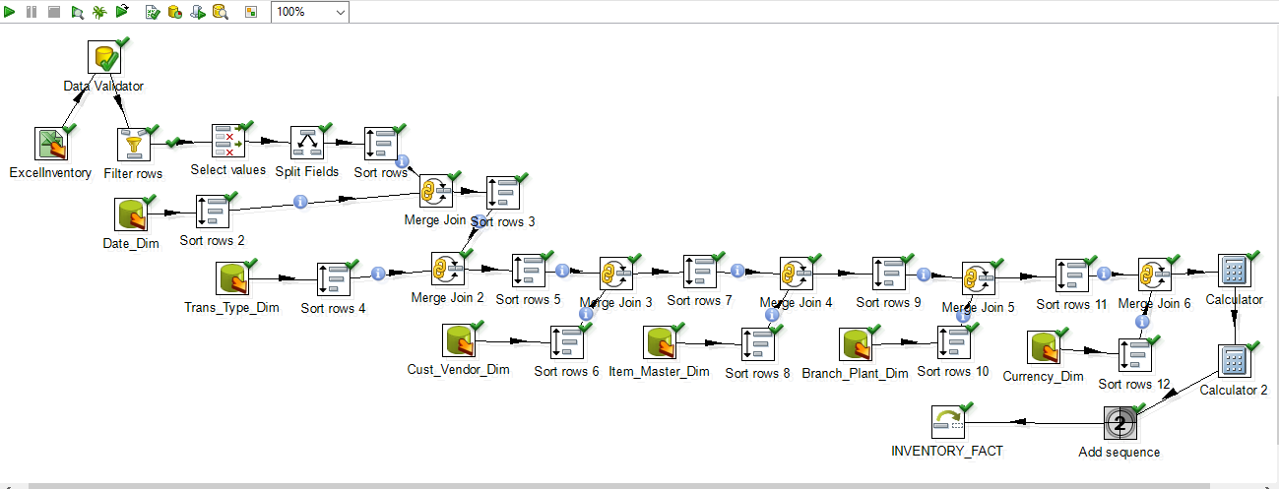

**AFTER RUNNING OF TRANFORMATION, THEN**

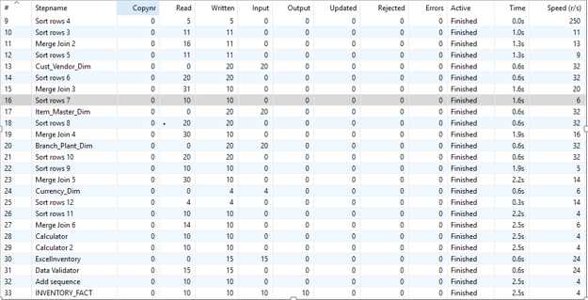

**INVENTORY FACT TABLE**

